Hoarding and decluttering/deep cleaning service

Referral Information

Referrer’s Contact Details
Date of referral:-

Referrer’s Name | Position
Phone: | Mobile:
Email address:

Client Details

Title: Miss Forename(s): Surname:

Marital Status:
Known as: | Date of Birth: |  |  | Phone:  Mobile:
Address:
First Language: English |  | Other Languages Spoken:
Service User Understands English? Yes No

Email:

Religion: |  |  | Ethnicity:
Culture:

Is this an urgent referral? YES NO
Has the property had a Safe and well visit from the fire service? YES NO

Has the Fire Service been informed if the property is heavily cluttered? YES NO

Clutter Image Rating Scale - Bedroom

Please mark the photo number that most accurately reflects the amount of clutter in the room

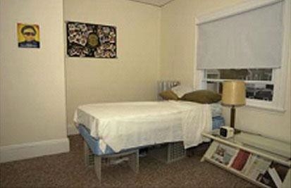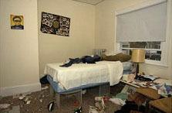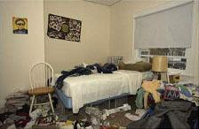

1 | 2 | 3

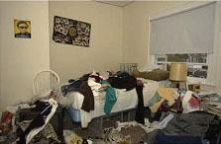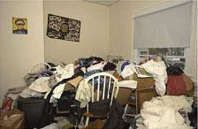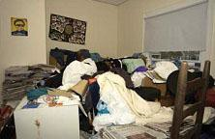

4 | 5 | 6

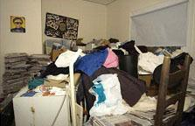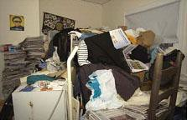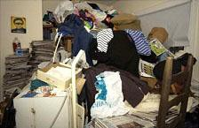

7 | 8 | 9

Please list any noticed fire risks:

Please indicate if escape routes/walkways are clear:

Clutter Image Rating Scale - Lounge

Please mark the box below the photo that most accurately reflects the amount of clutter in the room

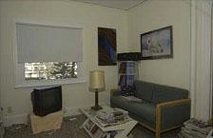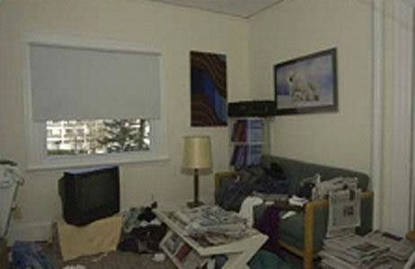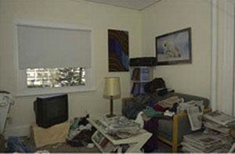

1 | 2 | 3

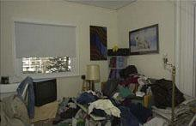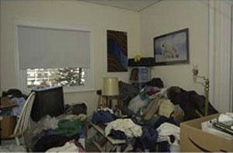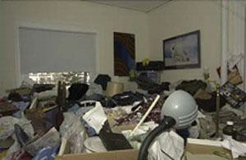

4 | 5 | 6

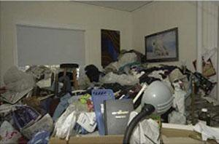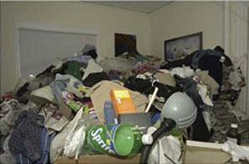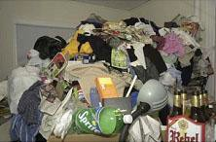

7 | 8 | 9

Please list any noticed fire risks:

Please indicate if escape routes/walkways are clear: Following the visit from the fire brigade an escape route has been made clear to enable access through the back garden in the event of a fire.

Clutter Image Rating Scale – Kitchen

Please mark the box below the photo that most accurately reflects the amount of clutter in the room

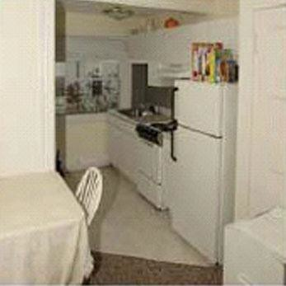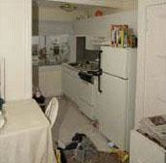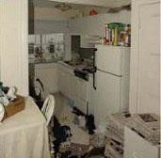

1 | 2 | 3

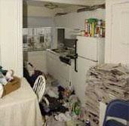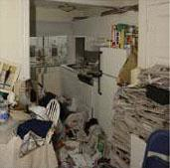

4 | 5 | 6

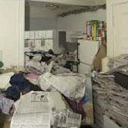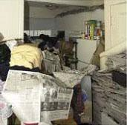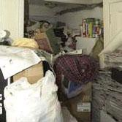

7 | 8 | 9

Please list any noticed fire risks:

Please indicate if escape routes/walkways are clear:

[Grab your reader’s attention with a great quote from the document or use this space to emphasize a key point. To place this text box anywhere on the page, just drag it.]

Other Special Needs – Provide details of any other special needs relating to the support they require.

CONTACT INFORMATION

Details of Main Carer/Relative:  Name:  Relationship: | Phone: | Mobile:
Address:

Email

SERVICE USER BACKGROUND INFORMATION

Has Client recently been in hospital? NO

Is the client currently in hospital? NO

If YES to either question please complete the following information for the past year.
Dates of stay in hospital | Reason for hospital stay

Risk within property

Please state if there is a known current infestation/history of infestation: | Please state if there is any known risk from sharps/needles/glass:
Please state if there is a known risk from the structure of the property: | Please state if there is any risk from pets/animals:
Risk Assessment: Has a recent risk assessment been completed by referrer? YES NO .

If yes please provide with referral

Has client been a victim of rogue trading? NO

distraction burglary? NO

Mail/telephone scams? NO

